TO: City of Albany Industrial Development Finance Committee
FROM: City of Albany Industrial Development Agency Staff
RE: South End Second Ave LLC - IDA Application Summary
DATE: September 5th, 2025

Applicant: South End Second Ave LLC

Managing Members (% of Voting Interest): MDG-RNY Development Owners, LLC (50%), Novis Albany South End LLC (50%); please see application addendum for a full breakdown of the ownership interests.

Project Location: 64-parcel scatter site located on Broad Street, Clinton Street, South Pearl Street, Teunis Street, Second Avenue, and Third Avenue. Please see Appendix A to the application for a more detailed view of the site.

Project Description: The project involves the redevelopment of sixty-four vacant and underutilized parcels into 166 units of affordable housing. The Project will total 62 new buildings containing approximately 159,687 sf of residential space, 1,674 sf of commercial space, and 26,048 sf of common area. The residential units will serve income qualifying residents that fall between 50% and 80% of the area median income.

Estimated Project Real Property Benefit Summary (30 Years):
 | Status Quo Taxes  (no project)  Non-Homestead Rate | Project Impact (PILOT Payments) | Net Benefit
Revenue Gain to Taxing Jurisdictions | $1,095,736 | $4,560,988 | $3,465,252

 | Current Value | Anticipated Future Value* | Net Increase
Property Value Increase | $768,500 | $11,820,000 | $11,051,500
*Project Impact Assessed Value based on letter from the City of Albany Assessor dated 6-03-25

At the end of the PILOT period, the project is anticipated to make annual tax payments to the taxing jurisdictions of $607,432 based on an assessed value of $11,820,000 and an annual tax rate of $66.09.

Estimated Investment: $97,371,504 (est.)

Community Benefits: For comparative purposes, please see the attached CAIDA Project Evaluation and Assistance Framework Staff Analysis for more detail on the Community Benefits metrics below. Please note that due to the fact that the project involves purpose-built affordable housing, the project was evaluated outside of the Project Evaluation and Assistance Framework.
- Revitalization: The project is located a high vacancy census tract; the project is located in a distressed census tract; the project is located within a neighborhood plan.
- Identified Priority: The project supports multiple initiatives within the Albany 2030 Plan; the project also includes the redevelopment of a tax exempt/vacant property

- Job Creation: The project is committing to the creation of two (2) full-time equivalent and one hundred (100) construction jobs.

- Investment: The project is anticipating a project cost exceeding $97 million.

Employment Impact Analysis:

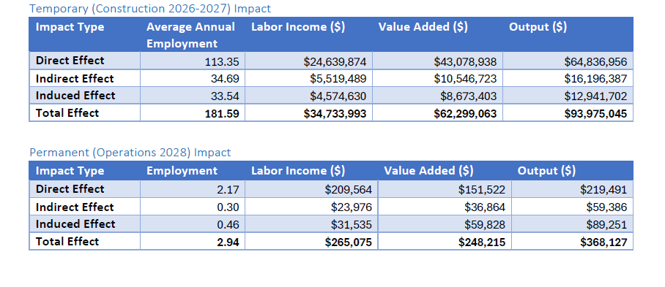

*IMPLAN Economic Impact Analysis conducted by the Capital District Regional Planning Commission as of 7/30/2025.

Employment Impact:
- Projected Permanent: 2 jobs
- Projected Retained: 0 jobs
- Projected Construction: 100 jobs

Type of Financing: Straight Lease

Amount of Bonds Requested: None

Estimated Total Purchases Exempt from Sales Tax: N/A

Estimated Total Mortgage Amount: N/A

Requested PILOT: The proposal entails the Applicant entering into a 30-year PILOT agreement with the IDA including shelter rent payments of five percent (5.0%) for the term of the agreement, which is a deviation from CAIDA policy.

Third Party Review: Due to the special nature of the requested deviation in assistance from the Agency Policy Manual, a third-party evaluation of the appropriateness of the applicant’s PILOT request has been commissioned. The third party determined that the assumptions included within the application in addition to the abatements requested were within reasonable parameters.

Estimated Value of Tax Exemptions:
- NYS Sales and Compensating Use Tax: $0
- Mortgage Recording Taxes: $0
- Real Property Taxes: $9,043,340
- Other: N/A

Baseline Requirements:
- Application: Complete
- Meets NYS/CAIDA Requirements: Yes
- Albany 2030 Alignment:
- Increase job opportunities for all residents.
- Encourage investment in urban land and buildings for employment and housing.
- Reuse of vacant and abandoned properties.
- Remove blighting influences.
- Planning Approval Status: Full Planning Board approval received in May 2025.
- Meets Project Use Definition: Yes
- Meets “But For” Requirement: Yes, affidavit signed.

Cost Benefit Analysis: See attached Exhibit A: Description of The Project Evaluation and Expected Public Benefits.

Estimated IDA Fee
- Fee amount: $973,715.04

CAIDA Mission: Assist in the enhancement and diversity of the economy of the City of Albany (the “City”) by acting in support of projects in the City that create and/or retain jobs and/or promote private sector investment utilizing the statutory powers of the Agency as set forth under the provisions of the laws of the State of New York.

The parcels included in this project are currently tax-exempt. Status quo taxes were calculated using the non-homestead rate for the duration of the PILOT period for comparative purposes. The properties currently generate $0 in revenue to the taxing jurisdictions.

